**My First Image:**

1. **Learned Docker commands**
2. **Started creating first simple image using Docker file, build image and ran containers and tagged the image and pushed the image to Github.**
3. **Simple Docker file below:**

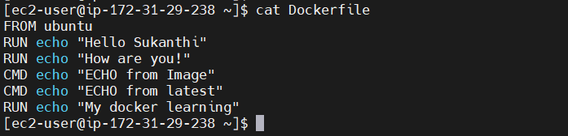

1. **Image build using Docker file.**

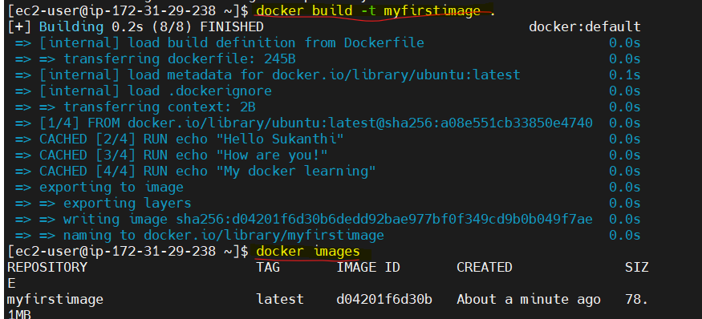

1. **Run container with the myfirstimage either by image name or idA black background with white text

   AI-generated content may be incorrect.**
2. **To tag the image and ensure docker login done.** 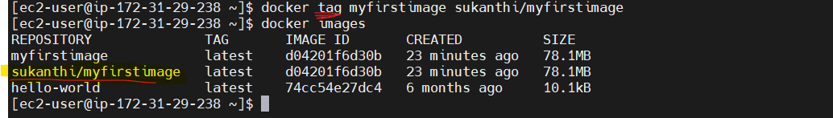
3. **To push this image to docker hub. A screen shot of a computer

   AI-generated content may be incorrect.**
4. **Post the push, image pushed to docker hub repo.**

1. **Creating a shell script for addition: addition.sh**

**#!/bin/bash**

**a=$1**

**b=$2**

**sum=$((a + b))**

**echo "Result: $a + $b = $sum"**

1. **Write a docker file to expose this to internet using ngnix.**

**FROM ubuntu**

**WORKDIR /app**

**# Copy all files into the container**

**COPY . /app**

**RUN apt-get update && apt-get install -y bash**

**RUN chmod +x addition.sh**

**# Set default command to run the script**

**ENTRYPOINT ["sh", "addition.sh"]**